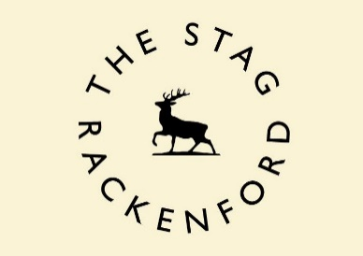

[www.thestagrackenford.co.uk](mailto:eat@thestagdevon.co.uk)

Tel: 01884 881755

Exmoor Food Festival Lunch

Available Thursday to Saturday

From 12th Feb to 29th Feb, excluding Valentine’s Day

£15 two courses / £17.50 three courses

During the Exmoor Food Festival, we are featuring on our lunch menu, free range pork raised by us on our small holding and on our dinner menu, Dexter beef raised by Adam Fausset at King’s Nympton. Our bread is, as usual, baked daily here using the beers on each day and with organic rye and unbleached white flour from Stoate’s watermill in Dorset. We use fresh eggs from Andrew and Sally Meikle at Great Whitstone Farm.

Starters:

* Broccoli & Stilton soup, home made beer bread
* Ham Hock Terrine, piccalilli
* Breaded Welsh Rarebit

Mains:

* Dexter Beef Stuffed Cabbage roll, tomato ragu and tenderstem
* Rolled Loin of Pork, dauphinoise potatoes, carrots and tenderstem
* Chickpea and Corriander Burger, hand cut fries

Desserts:

* Home made Madagascan Vanilla ice cream
* Lemon Possett with almond and fennel biscotti
* Apple & Blackberry Crumble, fresh vanilla custard